**Installing Java**

Installation of our Java development environment involves 3 operations.

1. Installation of the Java Development Kit (JDK) version 8
2. Installation of JCreator (our Java IDE) version 4.5 Lite Edition
3. Setting the Path variable (optional).

**Installing the JDK and JRE**

1. In the Installer folder on your Java DVD, double-click on the file jdk-8u261-windows-x64.exe.
2. The setup window should open

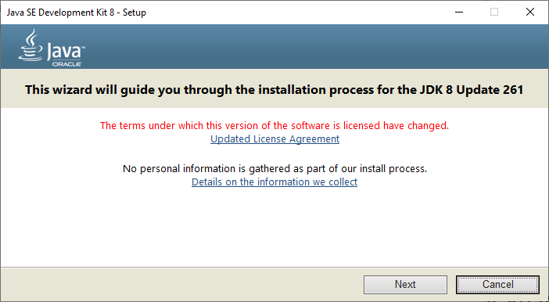

1. Click Next
2. The Custom Setup Window will open

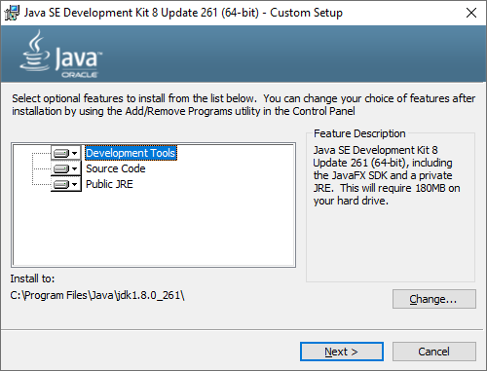

We will be installing the Development Tools, Source Code, and Public JRE (Java Runtime Environment) to your hard drive at location C:\Program Files\Java\jdk1.8.0_261\

1. Click Next and you will see the installer get prepared.
2. The Destination Folder window will open (we will not change this)

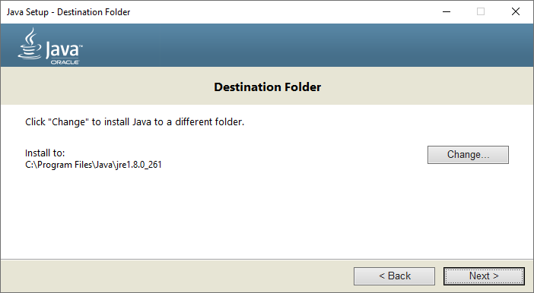

1. Click Next and the JDK will install.
2. The Complete window will open

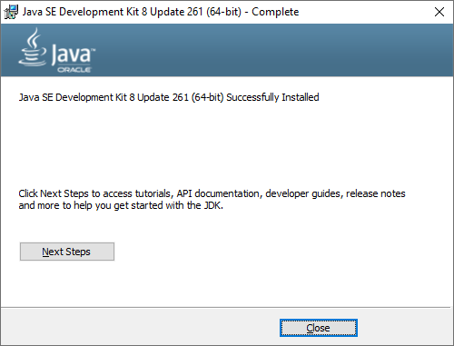

1. Click the Close button

**Installing JCreator**

1. In the Installer folder on your Java DVD, double-click on the file jcrea450_setup.exe.
2. The JCreator LE Setup Wizard will start. Click Next.

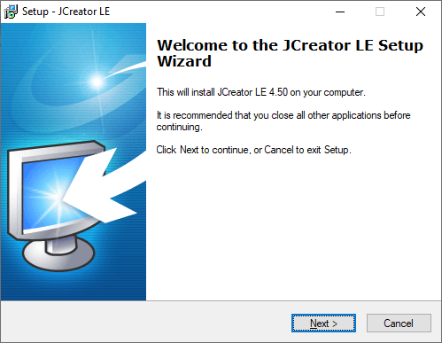

1. Accept the agreement and click Next

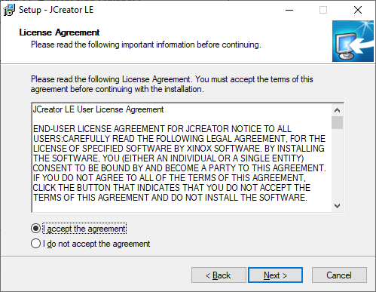

1. The destination location window will open and click Next.

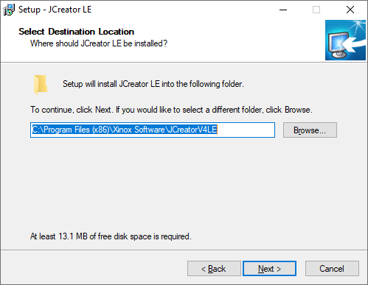

1. The folder needs to be created so click Yes.

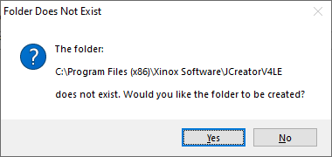

1. The Start Menu Folder window opens. Give it the name JCreator and click Next.

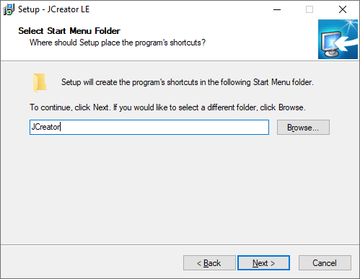

1. Create a Desktop Icon and click Next.

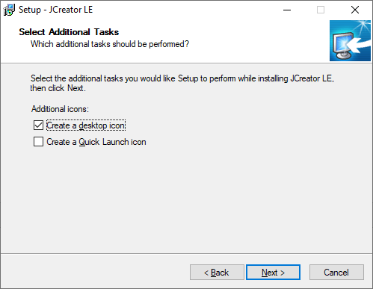

1. The Ready to Install window opens and click Install.

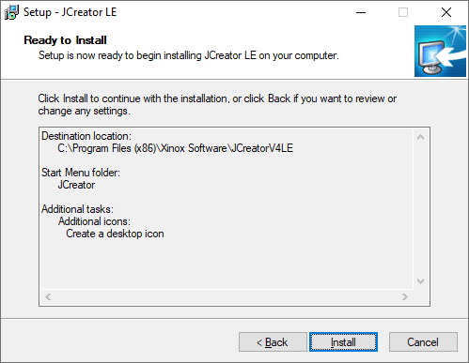

1. The installation is now complete. We are going to launch JCreator and setup the environment.

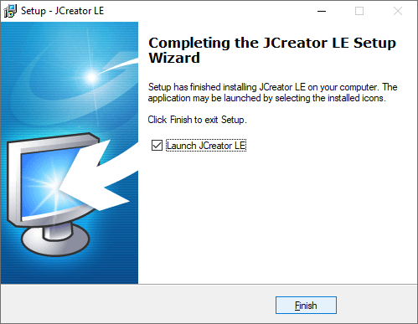

1. Before we setup JCreator, we need to copy the Java 8 Docs folder from the Installer folder on the Java DVD to the following location.

C:\Program Files\Java

1. Click Finish and the JCreator Setup Wizard will start

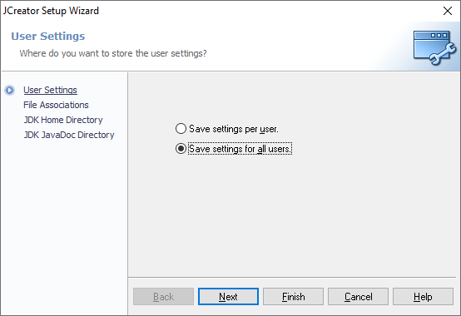

1. Save settings for all users and click Next.
2. The File Associations window will open. Click Next.

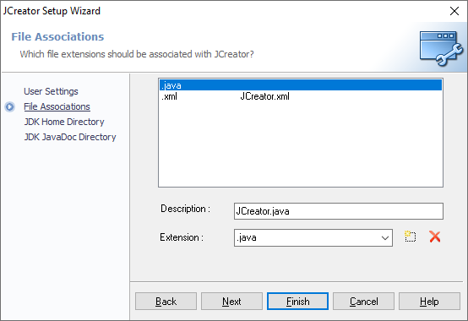

1. The JDK Home Directory window will open. Set the home directory to C:\Program Files\Java\jdk1.8.0_261 and click Next.

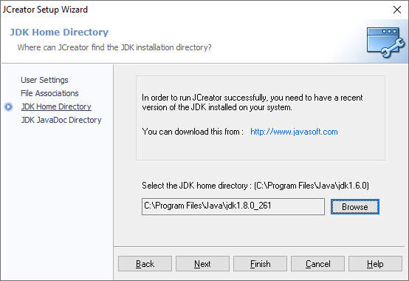

1. The JDK JavaDoc Directory window will open. Set the home directory to C:\Program Files\Java\Java 8 Docs and click Finish.

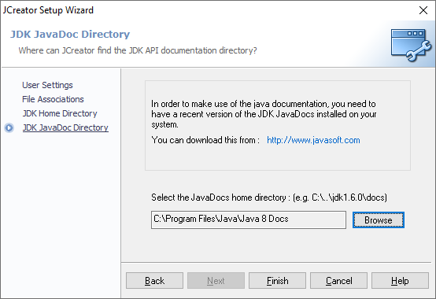

1. JCreator will then start and the JCreator setup is complete.
2. Select File|New|Project.

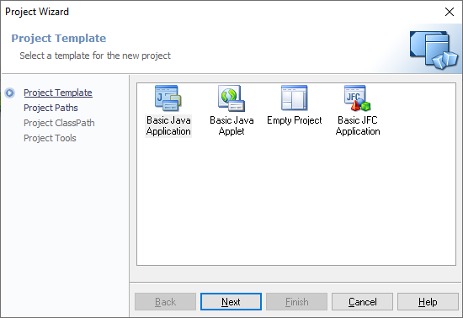

1. Select Basic Java Application and Next.
2. Name the project Hello and click Next.

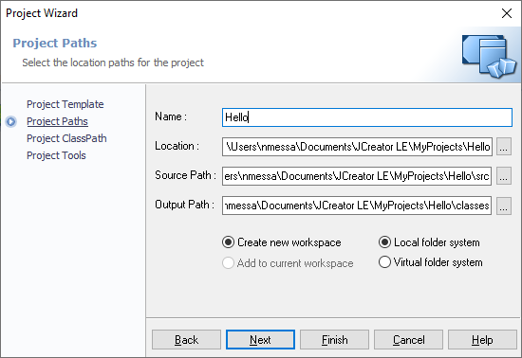

1. The Project ClassPath window will open. Click Next.

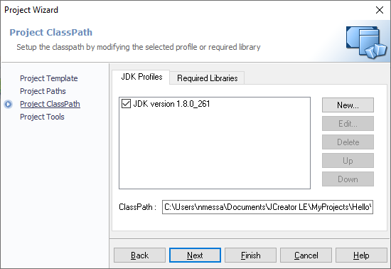

1. The Project Tools window will open. Click Finish.

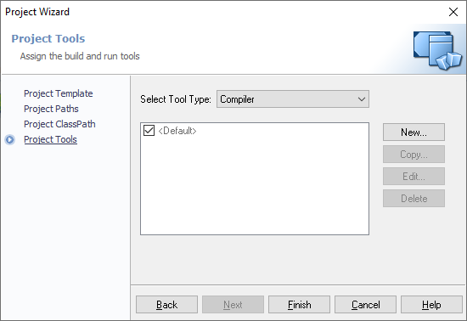

1. The Project Creation window will open. Click Finish.

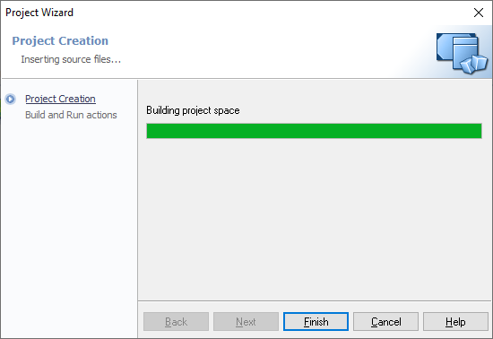

1. The project is now built. Click the Run Project button (or hit F5).

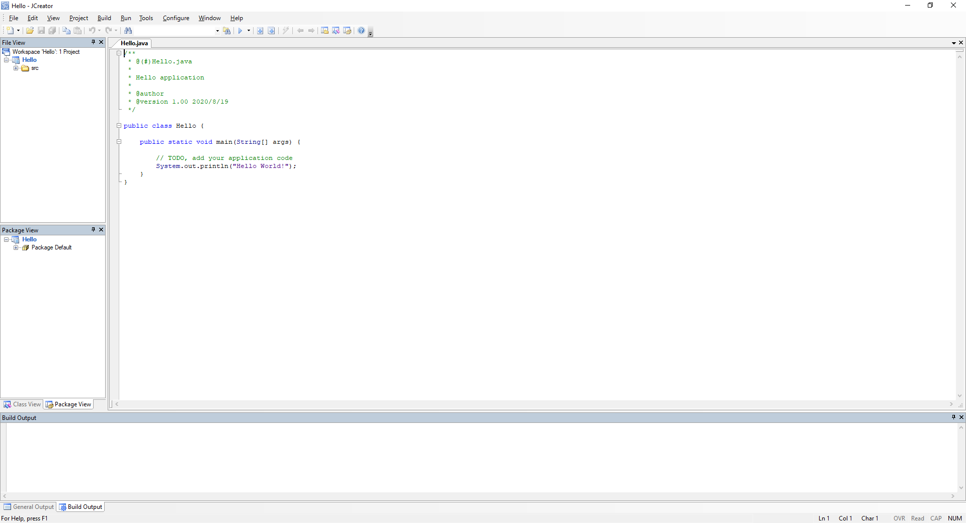

1. Notice the output.

